Paper Title (confined and clear)
First Author¹, Second Author², Third Author³, Fourth Author²
¹Full name of the Institute of first author
²Full name of the Institute of the second and fourth author
³Full name of the Institute of the third author
Corresponding Author’s Email- xyz@xyz.ac.in

Abstract
Abstract in the range of 100-250 words. The following points must be described in the abstract body-
- The objective of the study
- The adopted methodology in the research
- Materials, Parameters and boundary conditions applied in the anlysis
- The expected outcomes of the study

Keywords
Keyword-1, Keyword-2, Keyword-3 (At least three keywords separated by comma)

Introduction
The background of the work, literature review and the literature gap must be highlighted in the Introduction part. All the references, figures, tables and equations must be cited in the paper body [1-2]. All the important sections like Literature review, Problem statement, Parameters, methodology, result and discussion must be explained properly.

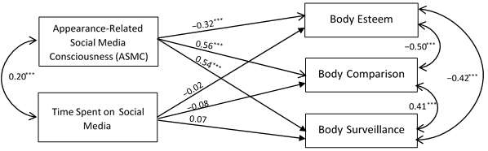

Figure 1 Sample Diagram

Sub Heading-1
Table must be typed in word. Table in image or any other format will not be accepted.

Table 1 Sample caption
S.No. | Head 1 | Head 2 | Head 3 | Head 4
1 | Sample data | Sample data | Sample data | Sample data
2 | Sample data | Sample data | Sample data | Sample data
3 | Sample data | Sample data | Sample data | Sample data
4 | Sample data | Sample data | Sample data | Sample data
5 | Sample data | Sample data | Sample data | Sample data

Sub Heading-2

Conclusion
The outcomes and future scope of the work must be summarized in the conclusion section. The data quantification in % or as indices must be included in the conclusion part.

References
IEEE reference style must be followed as-
- Shuafeng Wang, Junyou Zhang and Qun Yu, "Design Virtual Experiment of Vehicle Using ADAMS", Journal of China Agricultural University, vol. 6, no. 6, pp. 81-84, 2001.

